Konsel Pluw Erens Gerrans Parish Council.

Notice of the Parish Council Meeting
Tuesday 6th October 2020 at 7:30pm

All members of the council are hereby summoned to attend for the purpose of considering and resolving upon the business as set out in the agenda. Due to the current Coronavirus Covid-19 restrictions this meeting will be a virtual meeting on the Zoom platform.

Members of the public wishing to attend and listen to proceedings are invited to apply to the clerk for joining instructions. This is a public meeting and as such could be filmed or recorded by broadcasters, the media or members of the public. Members of the public should notify the clerk in advance if they wish to speak during the period allowed for public participation.
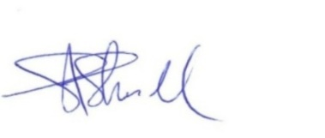

Steven Skull (Clerk) Dated this 30th September 2020
Agenda

- Roll call of members attending
- To confirm that the meeting is quorate.
- Apologies for absence
- To receive apologies and approve absences.
- Declarations of interests in items on the agenda
- Disclosable pecuniary or non-registerable interests.
- Gifts to the value of more than £25.00.
- To consider requests for dispensations on items on the agenda
- Public participation
- Members of the public may address Councillors on any item on the agenda for a maximum of 15 minutes and for no longer than 5 minutes per person.
- Decisions
- To review for ratification the list of decisions made from 6th August 2020 to date under the Council’s Emergency Scheme of Delegation.

(Continued below)

Agenda (continued)

- Roseland Environmental Action Community Team
- To receive a report and update from Cllr Richard Cochrane

- Annual Governance and Accountability Return for the year ended 31st March 2020
- To review for approval the Notice of Conclusion of Audit from the Council’s external auditors.

- Clerk’s terms and conditions of employment
- Annual review

- Next Meeting
- To decide date and venue of next meeting.

- Meeting Close

Gerrans Parish Council,
1, Cott Villas,
Cott Road,
Lostwithiel,
Cornwall
PL22 0ET
clerk@gerransparishcouncil.org
Telephone: 01208 872285

